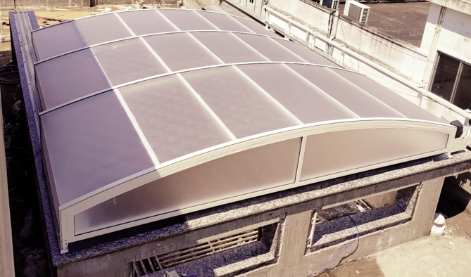 | 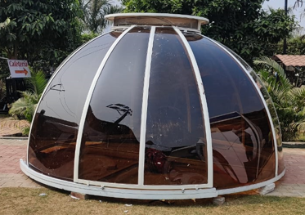 | 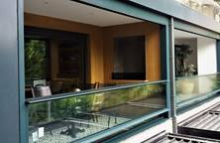
Automatic retractable roof - Add more splendour by allowing partial sunlight and night sky views. | Dome enclosure - Unique design for outdoor open-air-living. | Automatic vertical sliding window - Better utilization of space, and even a better air ventilation scheme.
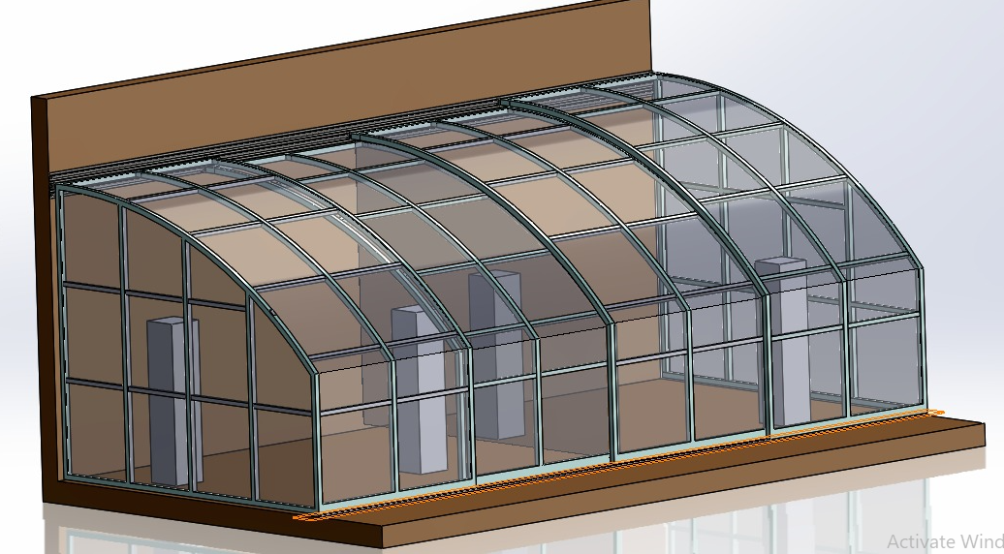 | 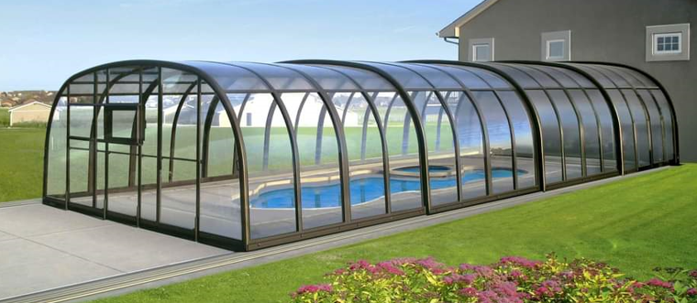 | 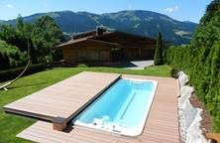
Balcony enclosure –  Enhances the idea of open air sitting with panoramic view. | Swimming pool enclosure –  Protecting pool to | Swimming pool deck-  Automatic cover that doubles up the functioning the deck.
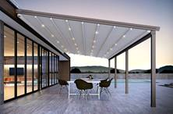 | 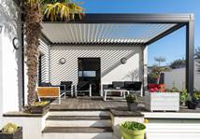 | 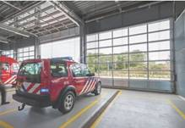
Retractable fabric roof (Pergola) – To create and outdoor luxurious, weather protected space. | Rotating louvers- Provides right amount of light and shed and protection from sun, rain and dew. | Garage sectional door – Good control over interior environment to create and maintain optimum air conditioning.
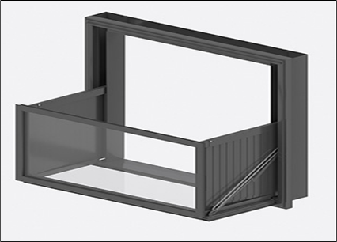 | 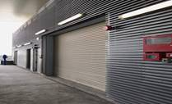 | 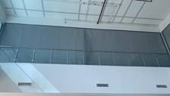
Foldable window balcony- An innovative product from NIHVA that converts the window into balcony | Fire rated rolling shutter – Close automatically on fire detection, and prevent the spread of fire and smoke. | Fire curtain - The best equipment for compartmentalizing the building, isolating the hazardous and high-risk areas.

